**EGERTON UNIVERSITY-NJORO CAMPUS**

**PROCUREMENT’S STOCK MANAGEMENT SYSTEM TECHNICAL DOCUMENT**

**GROUP 5**

**GROUP MEMBERS**

Benjamin M. Makau S13/15311/16

Joakim Adeny S13/15350/16

Dedan Msafari S13/15328/16

Rose Ngomo S13/15312/16

Victor Kiplangat S13/15332/16

Naftaly Kariuki S13/15333/16

Contents

1. INTRODUCTION 5

2. OBJECTIVES 5

3. PROJECT SCOPE 5

4. PURPOSE OF THE PROJECT. 5

5. FUNCTIONAL REQUIREMENTS OF THE SYSTEM 6

i. User requirements 6

a. User Profiles 6

b. Task Profiles 7

ii. System interface requirements 8

a. Inputs and outputs 8

b. User interface standards requirements 8

iii. Hardware interfaces 8

iv. Communication interfaces 8

v. Other software interfaces 8

6. NON-FUNCTIONAL REQUIREMENTS 9

i. Security 9

ii. Performance 9

iii. Operational 9

iv. Availability 9

v. Usability 9

7. FUNCTIONAL MODELS 10

i. Flow of events 10

ii. Use case diagram 11

iii. Activity diagram 12

a. Admin’s activity diagram 12

b. Client’s activity diagram 13

c. Manager’s activity diagram 14

d. Sequence diagram 15

e. The state chart diagram 17

f. Class diagram 18

8. PROJECT MANAGEMENT PLAN 19

i. Purpose of Project Management Plan 19

ii. Assumptions/constraints 19

iii. Work breakdown structure 20

iv. Project schedule 20

Milestones 20

v. Dependencies 21

vi. Budget management 21

vii. Quality management 21

viii. Human resource management 21

ix. Risk management 21

x. Deployment and procurement management 21

xi. Compliance related planning 21

xii. Project management plan approval 22

xiii. Conclusion 22

9. SOFTWARE DESIGN 22

i. Purpose and Scope 22

ii. System overview 22

iii. Design constraints 22

iv. Future contingencies 22

10. TEST PLAN 23

i. Purpose 23

ii. Audience 23

iii. Test objectives 23

iv. Test assumptions 23

v. Test principles 24

vi. Data approach 24

vii. Test assumptions 24

viii. Test principles 24

ix. Data approach 25

x. Scope and levels of testing 25

a. Functional Test 25

b. System Testing 25

c. Integration Testing 25

d. Regression Testing 25

e. User Acceptance Testing 25

11. ROLES AND EXPECTATIONS 25

i. Project management 25

ii. Test Planning 26

iii. Test Team 26

iv. Development Team 26

Software Requirement Specification Document for a Stock management system.

# INTRODUCTION

This is a project that aims at developing a user-friendly software that will fulfill all the tasks, goals and objectives of stock management. This system will be used by the procurement department at Egerton University in conjunction with all the respective departments in the university to ensure proper record keeping of all supplies. It is also aimed at simplifying the process of ordering of supplies by every department in the university. This will particularly be done by use of online order forms as this system will be web based.

# OBJECTIVES

* This project aims at developing a user-friendly software that will automate the stock management at the procurement department. Currently the department relies heavily on manual methods for record keeping and identifying items that are out of stock. This has led to inadequate purchase of supplies of purchase of items in excess.
* This system should be able to counter and negate all drawbacks that arise from the use of manual methods.
* It will also automate requesting of supplies by the various departments in the university.

# PROJECT SCOPE

* The Stock Management System is a web-based application that is used by the procurement department within Egerton University for efficient operation and management of the university supplies. The system enables easy record keeping and stock management to ensure university resources are well utilized.
* It basically enables administrator to create accounts for respective users and manage the users in the system. The other users are members from other departments in the university and a stock manager who will be in charge of the procurement department’s store. The store manager will perform most of the basic tasks in the system.
* Users from other departments will only be required to submit order forms for the purchase or dispatch of supplies they need.
* The system also keeps record of all the available supplies in the database to ensure that supplies are not procured in excess.

# PURPOSE OF THE PROJECT.

* This project will create a tool for automated stock management which will include the following tasks:
* Viewing of the items in store.
* Check if supplies requested by departments are in store.
* Update of items in store.
* Receiving of new items in store.
* Dispatch of items from the store to various departments.
* Create new items.
* Submit order forms from departments.
* Delete items from the system.
* The main goal of the store management system is to ensure consistent availability of supplies to various departments and ensure that correct records of the existing supplies are kept. This will help ensure that no items are purchased in excess while they still exist in the store. This will run as a client server software that will be available to multiple users and can be used concurrently from various departments, with the system administrators being users at the procurement department.

There are three users for this system:

* + Administrator.
  + Stock manager.
  + Department user.

# FUNCTIONAL REQUIREMENTS OF THE SYSTEM

## User requirements

### User Profiles

In the expected system users shall be defined by the following attributes:

* Which type of workstation they are using. Users will be accessing the system from the procurement department which in this case will be the administrating side. Other users will access the system from their various departments. This will only be for order form submission.
* Their authorized user type as assigned by the system administrator.
* Their authorized control level as assigned by the system administrator. This will determine what the user is capable of doing with the system from their work station.

### Task Profiles

The system shall support the following task profiles

|  |  |  |  |
| --- | --- | --- | --- |
| **#** | **Task** | **User type** | **Description** |
| 1 | Log in | All | All system users will be required to log into the system using the necessary credentials so as to access any services. This will be either a user name or email address and a password. |
| 2 | Manage user profile | All | Every user will have access to their user profile and will have the ability to edit their details from their work stations. |
| 3 | Request submission | Users from departments | Only users from all departments will be able to fill in order forms for supplies they need and submit the forms for evaluation. |
| 4 | View items in store | Store manager | Only the system administrators will be able to view logs of all the items in store. |
| 5 | Receive items | Store manager | This task will be performed when new supplies are procured by the procurement department for the respective departments. These new items will need to be received into the system. |
| 6 | Dispatch items | Store manager | This task will be performed when a department orders for supplies that are in store. The number of items ordered shall be automatically be deducted from the system for each particular item. |
| 7 | Create new items | Store manager | In a case where a department orders for items that are neither in the store nor in the system, the system administrator or the store manager shall be able to create a new item. |
| 8 | Delete items | Store manager | This will be performed for items that are no longer in use by the departments or are irrelevant. Once these items are not in store and are not required any more, they can be deleted from the system. |
| 9 | Manage users | Administrator | The system administrator will be able to create new users for the system. Users can not sign up on their own for purpose of security. The administrator can also delete users if needed. |

## System interface requirements

* This describes the interface of this system with other systems or the users of this system. There will be no interaction between this system and other systems. There will only be interactions between the system and its users.

### Inputs and outputs

* The system enables the users to input some details into it. Users will be required to input log in credentials. Departmental users will be required to input a list of supplies they need. The main input methods into the system will be by means of keyboards and pointing devices. E.g. mouse.
* The system will also allow output of information. The stock manager will need to view and print forms submitted by departmental users. The main output methods will be by means of screen displays and printing.

### User interface standards requirements

* The user interface standards for this system will be Graphical User Interface. This will require all users to have basic computer skills so as to comfortably interact with the system and fully optimize it.
* The graphical user interface will consist of a log in screen which will then be followed by menu of tasks.

## Hardware interfaces

* The system will run on pcs.
* It will also require printers for output purpose.

## Communication interfaces

* This system will be a web-based system.
* This means that communication will be accomplished via a network. A local are network will be required which we believe is already catered for by the university.

## Other software interfaces

* Since the system is web-based, it will be able to run on a browser, preferably a Firefox browser or a chrome browser all of which are free.
* The system will also require a database management system. We shall use a SQL database for this purpose.
* The system will also be required to run on an operating system, preferably a windows operating system from Windows 7 up to the current Windows operating system.

# NON-FUNCTIONAL REQUIREMENTS

## Security

Only the stock manager should be able to approve a request of an item by departments. The manager can only access the stock system after login in. anonymous users from the departments requesting items can just order items and are not able to view the stock updates. passwords should also be hashed using Bcrypt to improve the system security.

## Performance

the system should be fast in response to time it should enable the stock manager to view all request by the department and manage them effortlessly. On approval in denial of any request by department the department should be notified immediately.

the system should allow users to authenticate without delays.

## Operational

The system will run as an online platform (web based). It should also support multi-user that is multiple user’s users from different departments requesting for items simultaneously without causing problem to the system. The system should be applicable to technology standard that is window based.

## Availability

The system should always be available to the stock manager or the users in the department when needed the stock manager should always be able to get all the updates after items are added or given to the respective department.

## Usability

The system should be easy to use for both the user and the stock manager. If one is a user in the department, they should be able to login into the system and request for items from the procurement department .it should be easy for the stock manager to view the request from the departments and respond to them appropriately. The department should get the response immediately that is if the item is in the required quantity in the stock or is a new item or the manager has to order for more items for it to be enough.

# FUNCTIONAL MODELS

## Flow of events

|  |  |  |
| --- | --- | --- |
| Actor | Use case | description |
| 1. Admin | 1. Log in 2. Manage users. | 1. Admin logs in. 2. If details are incorrect try logging in again, else if they are correct admin can view system logs. 3. Admin can add new users or delete existing users form the system. |
| 1. Client | 1. Log in 2. Request submission | 1. Client logs in. 2. If details are incorrect try logging in again, else if they are correct client can make an order 3. The client can submit the order. 4. Order is processed. |
| 1. Store manager | 1. Log in 2. View items 3. Receive new items 4. Create new items 5. Delete items | 1. Manager logs in. 2. If details are incorrect try logging in again, else if they are correct manager can view the menu. 3. Manager can check the items in store. 4. Manager can receive new items that have been procured. 5. If an item is new in the store, the manager creates a new item in the system. 6. good of no more use to the university is deleted from the system by the manager. |

## Use case diagram

### 

## Activity diagram

### Admin’s activity diagram

### 

### Client’s activity diagram

### 

### Manager’s activity diagram

### 

### Sequence diagram

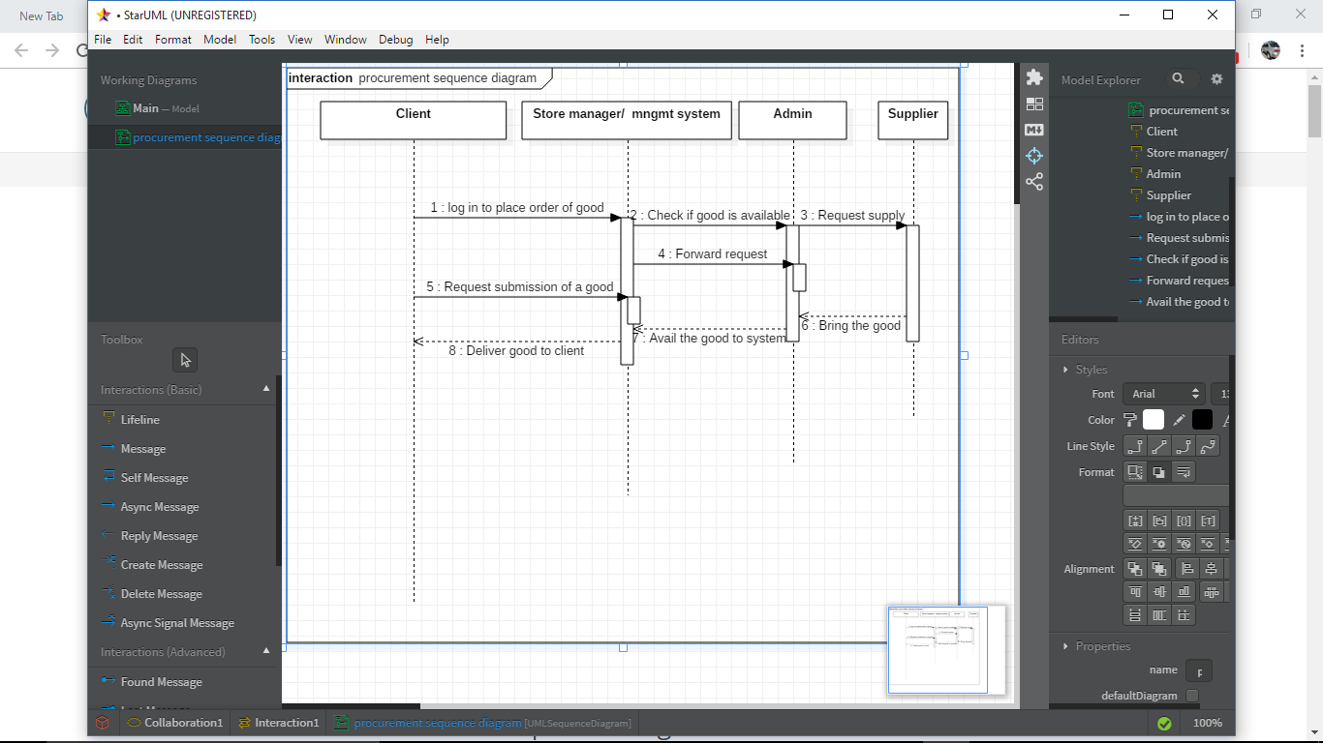

The flow of events in the sequence diagram:

* The client logs in to place an order through the procurement user interface and if credentials are correct as per procurement database, he or she is allowed to place an order.
* The store manager will check if good is available and notify the client. If not the order will be forwarded to the admin in order to request from the supplier supply missing requested good.
* Admin request to the supplier to supply the good in need.
* Request forwarded by store manager to admin.
* The client request for good be submitted by store manager.
* The supplier brings the new good to the admin.
* Through store manager the good is delivered to the client and records updated.

### The state chart diagram

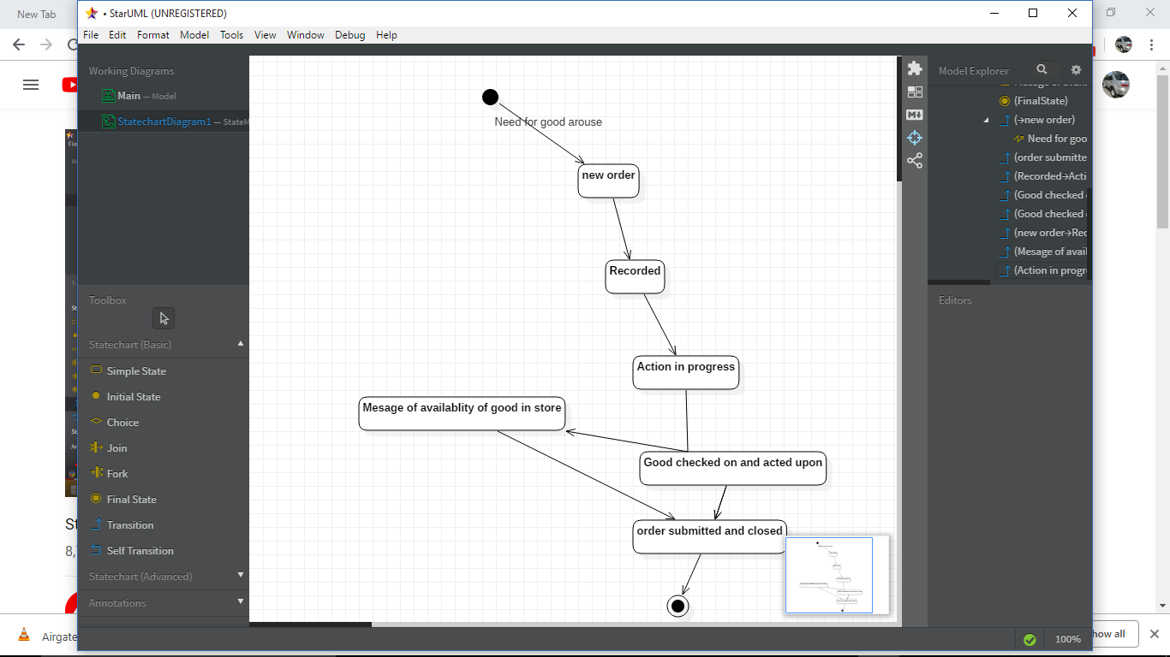

The flow of events in the state chart:

1. A need of a good or item arouse. it falls in the category of new orders.
2. It is recorded in the procurement database
3. The action is then initiated to satisfy the order
4. Action can take two-way output,
5. If a good is already in store, the request is halted and the order submitted and if good is not in existence new supply is made and the state come to its end point.

### Class diagram

### 

# PROJECT MANAGEMENT PLAN

## Purpose of Project Management Plan

The Project Plan will provide a definition of the project, including the project’s goals and objectives. Additionally, the Plan will serve as an agreement between the following parties: Project Sponsor, management Committee, Project Manager, Project Team, and other personnel associated with the project.

The intended audience of the project management plan is all project stakeholders including the project sponsor, the management and the project team.

The Project Plan defines the following:

* Project purpose
* Business and project goals and objectives.
* Scope and expectations
* Roles and responsibilities
* Assumptions and constraints
* Project management approach
* Ground rules for the project
* Project budget
* Project timeline
* Conceptual design

## Assumptions/constraints

The main assumption made while designing the system is that all the users of the intended system have basic computer skills and technology knowledge. This could also be the biggest constraint of this project. If clients or users lack these skills and knowledge, they will have to learn since it’s not costly.

## Work breakdown structure

|  |  |  |  |  |
| --- | --- | --- | --- | --- |
| **Level** | **Element Name** | **Description of Work** | **Deliverables** | **Resources** |
| 1 | UI | design | User interface | html, JavaScript, CSS, bootstrap |
| 2 | Database | Database design | MYSQL database | MYSQL |
| 3 | Program | Backend programming | Backend | php |

## 

## Project schedule

### Milestones

* The table below lists the milestones for this project, along with their estimated completion time frame.

| **Milestones** | **Estimated Completion TimeframeTThuse** |
| --- | --- |
| System analysis | Two weeks |
| System design | Three weeks |
| Back-end development (including database connection) | One month |
| Development of user Interface | 2-3 weeks |
| Testing The project | One week |
| Integration and backup | Two weeks |

## Dependencies

* The project mentioned above will have to follow a certain sequence until its completion. The project will start with system analysis for two weeks then followed by system design which takes two three weeks, when completed the implementation follows immediately, this takes about two months.
* The implementation of the project has two phases: one is front end development which take two to three weeks then the back-end part which takes one month. After all that, the project is then tested to check if all requirements are met. If so then it is integrated into a platform required. This approximately two weeks.

## Budget management

The mentioned system will be developed free of charge as it is a students’ project. The only cost incurred by the procurement department will be that of purchasing requirements.

## Quality management

* The mentioned system is expected to be elegant and of high quality. It is expected to meet all the requirements, perform all functionalities and be delivered within the mentioned time, cost, quality and be within the scope of the project.

## Human resource management

* This system will only require to be used by computer literate users. System update and maintenance will be conducted by the students while they are in session. After that, system update and maintenance may be done by the university’s IT department. Alternatively, the procurement department may decide to employee a person with required skills and knowledge to keep up with this after these students leave the university.

## Risk management

* Our system will ensure safety due some risk that might evolve during its deployment and installation and also during its use. These could arise as a result of unmet system specifications.

## Deployment and procurement management

* The intended users of this system shall be required to have either desktop computers or laptops in which the application shall be installed and run. The university shall therefore be required to facilitate this and ensure that users from every department interacting with this system have all the requirements.
* The system shall also require a database server which shall be procured by the university.

## Compliance related planning

* This relates to adherence to state laws and regulations. The system shall be designed in a manner that follows all laws regarding software development.

## Project management plan approval

The project management plan will require approval by all parties involved. This is to ascertain that the intended system meets all specifications, is within scope and has all the required functionalities.

## Conclusion

In conclusion, the system development is supposed to be done within a specified time period with minimum cost as possible. It should meet all requirements and be capable of performing all required functionalities. It should also be easy to use by all users interacting with the system.

# SOFTWARE DESIGN

## Purpose and Scope

The system will be designed for the purpose of stock management in the procurement department at Egerton University. It involves simplification by automation of record keeping in the department’s store and ordering of supplies by various departments in the university.

## System overview

This system is meant for record keeping and stock management. It will require three types of users who will be interacting with it. These will be:

* + Administrator.
  + Stock manager.
  + Department user.

## Design constraints

The system is web based so it requires an internet connection to work smoothly. We assume the intended users have an internet connection and that the browsers will be able to support this system. The system is designed to run well on the Firefox browser or chrome browser. The system is designed to be memory efficient.

## Future contingencies

With time, the system might require more storage space as it’s usage increases. This is with respect to the database server. The system might also be required to be updated with time as these browsers update. This is to ensure that this system is still supported by these browsers in the future.

# TEST PLAN

## Purpose

The following test plan provides the strategy to check on the accuracy of the stock Management System.

It includes:

* **Execution Strategy**: describes how the test will be performed and process to identify and report.
* Defects and strategy of negating them.
* **Test Strategy**: is an outline that describes the testing approach of the software development cycle. These could include, Objectives, assumptions, creation of test cases, specific tasks to perform, scheduling and data strategy.
* Test Management: the activity of managing the computer software testing process.

## Audience

* The various activities listed in this document will be carried out by the project team members. Thereafter, they will provide inputs and recommendations concerning the system. The Project manager will then organize for the activities involved in testing the whole system. In testing performance of the system, some people from procurement department and the other departments involved will be sampled to be participate in testing so as to ensure that system acceptance is realized. This will take place once the system is ready for deployment and use.
* Technical team selected has to ensures that the test plan and deliverables are in line with the design. They will provide the environment for testing and follow the procedure. The procurement department officials may provide what they have to say concerning the various functions that have changed and other relevant inputs to improve the system.

## Test objectives

This test plan intends to achieve the following objectives:

* To specify all procedures to be used in testing the system.
* To help check on the defects that may arise in the deployment of the system and identify the solutions to these defects.
* To check if the system has met the user requirements.

## Test assumptions

The following assumptions are going to be put into consideration when using this test plan:

* Production like data required will be available in the system prior to start of functional testing.
* Exploratory testing will be carried out once the build is ready for testing.
* Project manager will review and sign-off all test deliverables.
* The project team will provide test planning, test design and test execution support.
* Project team members have the knowledge and experience necessary in the system, the project and the testing processes.
* If the information shows correctly online and, in the reports, it will be assumed that the database is working properly.
* During functional testing, testing team will use preloaded data which is available on the system at the time of execution.
* Users have basic computer knowledge.

## Test principles

To manage this system testing plan, testing will be focused on the following principles:

* There will be consistent procedures common for all teams supporting testing activities.
* Testing processes will be well defined, but flexible, with the ability to change as needed.
* Testing activities will build upon previous stages to avoid redundancy or duplication of effort and will be focused on meeting the business objectives, cost efficiency, and quality.
* Testing will be divided into phases, each with clearly defined objectives and goals.

## Data approach

In functional testing, the system will contain pre-loaded test data and which will be used for testing activities.

## Test assumptions

The following assumptions are going to be put into consideration when using this test plan:

1. Production like data required will be available in the system prior to start of functional testing.
2. Exploratory testing will be carried out once the build is ready for testing.
3. Project manager will review and sign-off all test deliverables.
4. The project team will provide test planning, test design and test execution support.
5. Project team members have the knowledge and experience necessary in the system, the project and the testing processes.
6. If the information shows correctly online and, in the reports, it will be assumed that the database is working properly.
7. During functional testing, testing team will use preloaded data which is available on the system at the time of execution.
8. Users have basic computer knowledge.

## Test principles

To manage this system testing plan, testing will be focused on the following principles:

* There will be consistent procedures common for all teams supporting testing activities.
* Testing processes will be well defined, but flexible, with the ability to change as needed.
* Testing activities will build upon previous stages to avoid redundancy or duplication of effort and will be focused on meeting the business objectives, cost efficiency, and quality.

Testing will be divided into phases, each with clearly defined objectives and goals.

## Data approach

In functional testing, the system will contain pre-loaded test data and which is used for testing activities.

## Scope and levels of testing

### Functional Test

Functional testing will be performed to check the functions of application. The functional testing is carried out by feeding the input and validates the output from the application. This test will be performed according to functional requirements of the system.

### System Testing

System testing of software will be done on a complete, integrated system to determine if it meets the specified requirements.

### Integration Testing

This is carried out to confirm if the various parts of the system are working together. This will be done to ascertain that enough connection and integration of various system users was integrated.

### Regression Testing

This will test to see if any component which was added to the system has any effect on the existing ones. This will mostly deal with components relating to non-functional requirements.

### User Acceptance Testing

This test will focus on validating the business requirements. It will involve a few end users to check whether the system meets business requirements as specified in documentation.

# ROLES AND EXPECTATIONS

## Project management

All group members will be involved in project management. Every member will be required to take part in functionality development, testing of functionalities and debugging of the software.

## Test Planning

Test lead will be expected to undertake the following:

* Develop test plan and the guidelines to create test conditions, test cases, expected results and execution scripts.
* Provide guidelines on how to manage defects.
* Facilitate defect communications between testing team development team.

## Test Team

The team selected to facilitate testing of the system will be expected to undertake the following:

* Develop test conditions, test cases, expected results, and execution scripts.
* Perform execution and validation.
* Identify, document and prioritize defects.
* Re-test after software modifications have been made according to the schedule.
* Prepare testing metrics.

## Development Team

* Software development.
* Review testing deliverables (test plan, cases, expected results).
* Assist in the validation of results.
* Support the development and testing process.
* Certify correct components have been delivered to the test environment.
* Keep project team and leadership informed on development progress.
* Define processes and tools required for the digital migration.
* Defect identification and fixing.